**PROFILE**

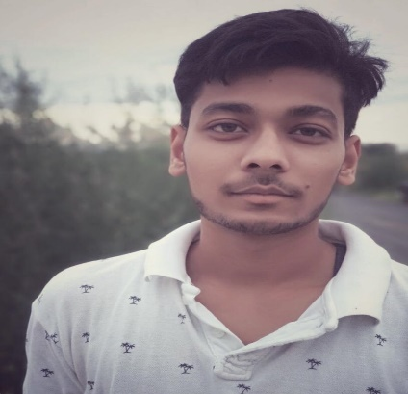

**ADITYA**

**Web Developer, Web Designer**

**SKILLS**

**Positive Attitude towards career Life in a Professional Approach to get the best result in the interest of organization ability to meet all sort of challenges in the course of Responsibility.**

* **HTML**
* **CSS**
* **Java Script**
* **Photoshop**

**CONTACT**

**EDUCATION**

391-mail4.png

aditya8814955719@gmail.com

**MAHARSHI DAYANAND UNIVERSITY**

**Bachelor OF COMMERCE**

**2018-2021**

067-phone.png

+91 9991754595

**C.DOT COMPUTER EDUCATION**

**Diploma in Computer Application**

**2017-2018**

001-home.png

**HOBBIES**

**Permanent address**

Kaushambi (U.P.)

**Present address**

Dharuhera, rewari ,Hariyana

032-book.png016-camera.png

Reading

Photography

018-music.png

Music